Java Lecture 8

**Java - Introduction to Programming**

**Lecture 8**

**Time & Space Complexity**

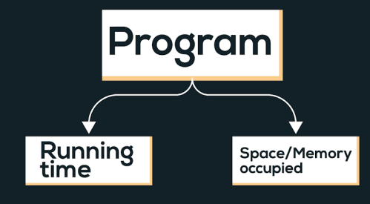

Time complexity of an algorithm quantifies the amount of time taken by an algorithm to run as a function of the length of the input.

Types of notations

1. O-notation: It is used to denote asymptotic upper bound. For a given function g(n), we denote it by O(g(n)). Pronounced as “big-oh of g of n”. It is also known as worst case time complexity as it denotes the upper bound in which the algorithm terminates.

2. Ω-notation: It is used to denote asymptotic lower bound. For a given function g(n), we denote it by Ω(g(n)). Pronounced as “big-omega of g of n”. It is also known as best case time complexity as it denotes the lower bound in which the algorithm terminates.

3. 𝚯-notation: It is used to denote the average time of a program.

**Examples :**

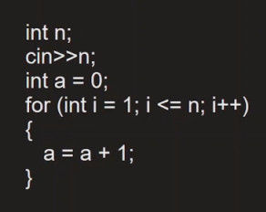

Linear Time Complexity. O(n)

**Comparison of functions on the basis of time complexity**

It follows the following order in case of time complexity:

O(nn) > O(n!) > O(n3) > O(n2) > O(n.log(n)) > O(n.log(log(n))) > O(n) > O(sqrt(n)) > O(log(n)) > O(1)

Note: Reverse is the order for better performance of a code with corresponding time complexity, i.e. a program with less time complexity is more efficient.

**Space Complexity**

Space complexity of an algorithm quantifies the amount of time taken by a program to run as a function of length of the input. It is directly proportional to the largest memory your program acquires at any instance during run time.

For example: *int*consumes 4 bytes of memory.

**Apna College**